CV09 — Belt Cleaning Without Effective Material Containment
FND-007 | CV09 | Surface Screening | Discharge / cleaner area | PROTOTYPE

CV09 provides a clear example of why belt cleaning and material containment must be considered as a single control function. Wet fines/slurry and return-side carryback were recorded around the discharge/cleaner area. The cleaner is positioned outside the effective discharge-chute containment boundary, so material removed from the return belt is not inherently captured within the intended downstream fines-handling path.
This matters because a cleaner can improve the return-belt condition while still transferring the material-loss problem to the surrounding plant if the removed fines are allowed to leave the process envelope.
CONTROL OBJECTIVE | Remove residual fines from the belt — and keep the removed fines inside the intended process stream.

MECHANISM / CONTAINMENT RELATIONSHIP
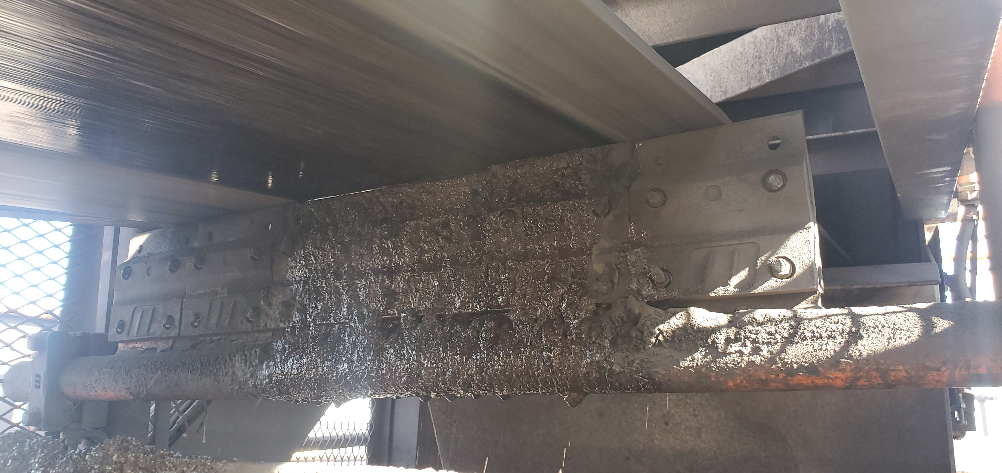
CV09-REF-003 — Cleaner/scraper assembly below the return belt, heavily coated with wet fines; the local cleaner region is visibly open to the surrounding structure.
CONSEQUENCE OUTSIDE THE PROCESS ENVELOPE
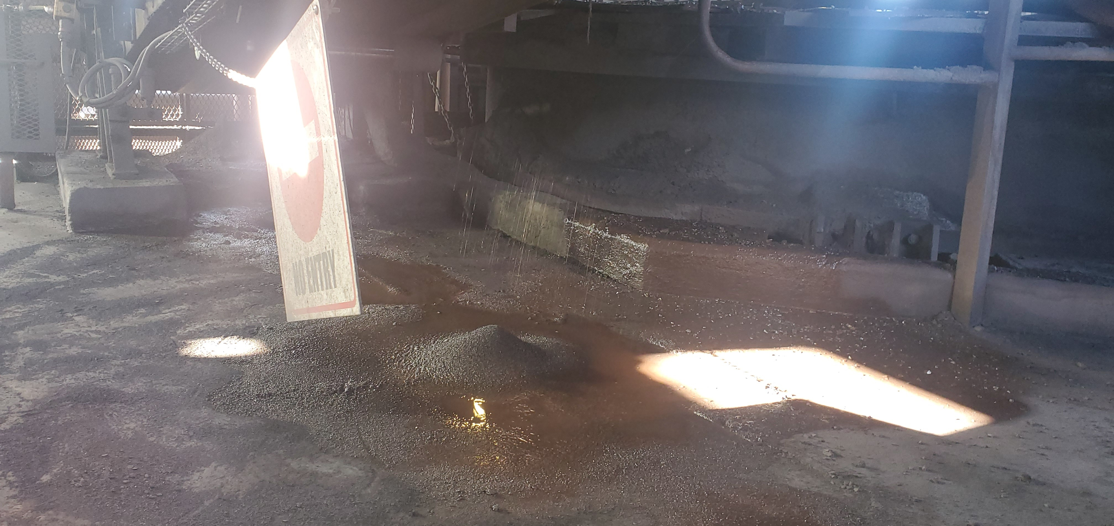
CV09-REF-002 — Wet fines/slurry and standing wet material beneath the discharge/cleaner region, confirming a substantial material-loss consequence in the surrounding plant area.

Operating Evidence and Engineering Response
The operating videos convert the CV09 condition from a static contamination record into an active-process finding. CV09-REF-006 shows wet material falling from the overhead conveyor/transfer region during operation. CV09-REF-008 provides close geometry/detail of the heavily fouled cleaner area used to understand the containment-boundary problem and develop the pilot concept.
DYNAMIC / DETAIL EVIDENCE
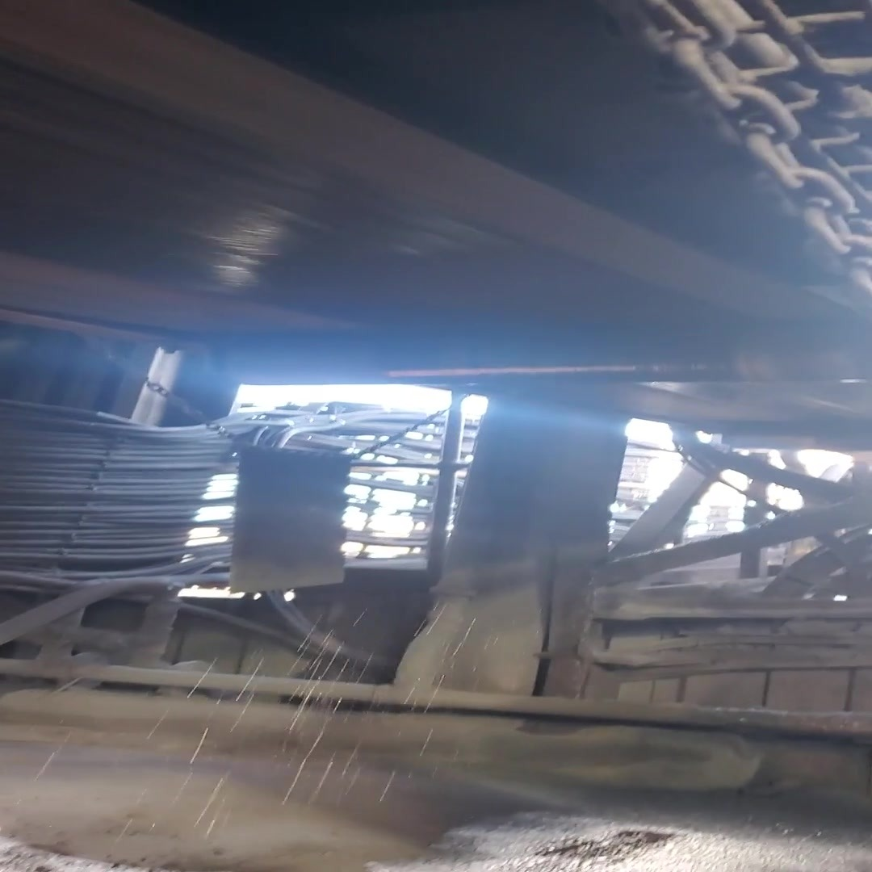  CV09-REF-006 — Representative frame from inspection video showing active wet-material fallout during operation.  The frame confirms an active condition in the region; it does not isolate the exact origin of every droplet. | 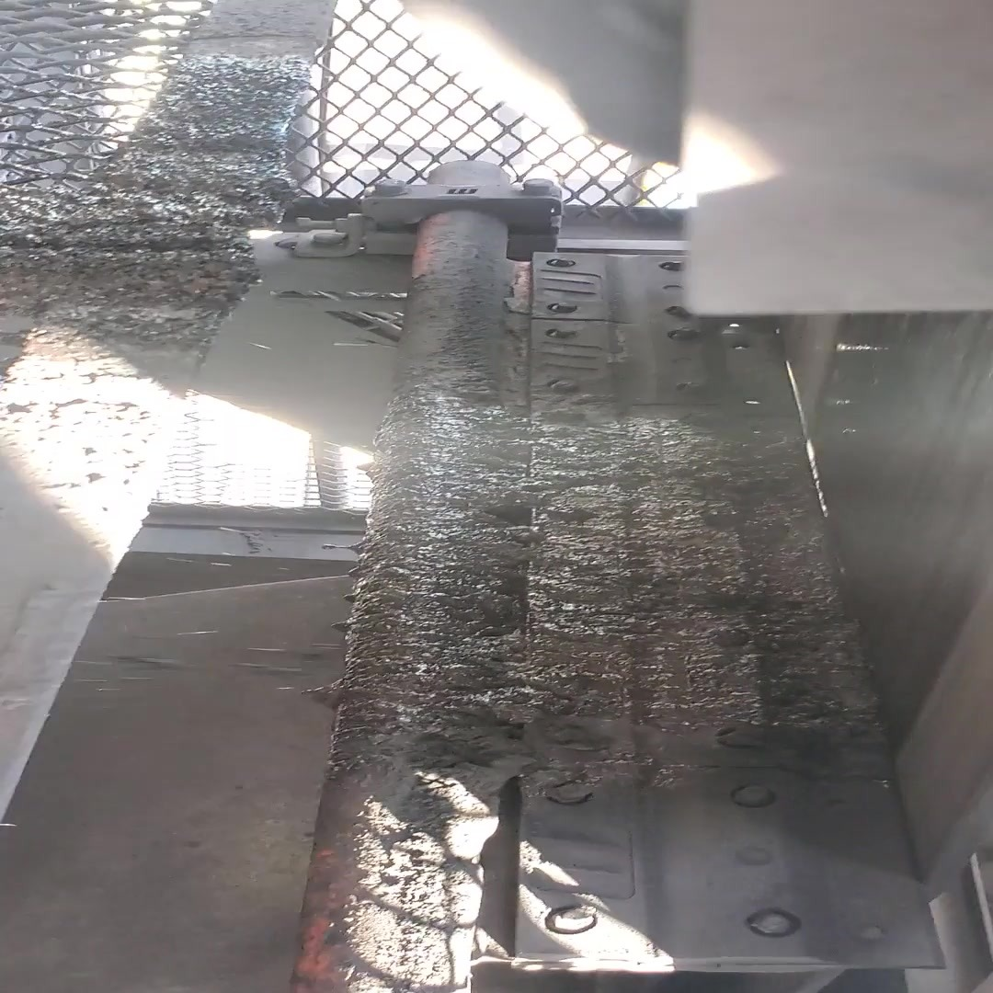  CV09-REF-008 — Representative frame from inspection video showing the heavily fouled cleaner/chute relationship used for containment-boundary and pilot-design understanding.  Final dimensions and cleaner/chute modifications require site measurement and detailed design.
EVIDENCE-TO-ACTION SUMMARY
OBSERVATION | Wet-fines/slurry accumulation is present below the CV09 discharge/cleaner region. The reviewed video also shows active wet-material fallout from the overhead conveyor/transfer region during operation.
ENGINEERING ASSESSMENT | The inspection record and cleaner/chute geometry show that the cleaner is positioned outside the effective discharge-chute containment boundary. The arrangement can therefore remove residual material from the belt without inherently retaining that material within the intended downstream fines-handling path. The video confirms the condition was active in the region, but does not isolate the exact origin of every droplet.
CONTROL PHILOSOPHY | Treat belt cleaning and containment of the removed material as one function: maintain effective cleaner contact, remove residual fines from the return belt, and keep the removed fines inside the intended chute/process envelope so they continue to the downstream fines-handling section.
RECOMMENDED NEXT ACTION | Develop and trial a CV09 cleaner/containment arrangement. Verify belt/discharge geometry, available containment envelope, cleaner mounting and wear compensation, safe access, maintainability, safety and the downstream fines route before finalising the design. If the pilot performs successfully, assess the functional philosophy for location-specific use at other suitable discharges.
Design status: CV09 is a pilot / design-development recommendation, not a completed fabrication design. Final cleaner type, contact pressure, chute dimensions, support details and maintenance-access geometry remain to be verified.

